Contitech
number of part - quantity
7PK1113 - 503

7PK1113
RENAULT MASTER 2.5 DCI
RENAULT TRAFIC 2.5 DCI

Verwendung:

RENAULT
MASTER III autobus (JD) -2003.10
2.5 dCi (120 KM) 2006.08- 2464 ccm88 kW 4 cyl
2.5 dCi (146 KM) 2006.08- 2464 ccm107 kW 4 cyl
2.5 dCi (101 KM) 2006.08- 2464 ccm74 kW 4 cyl
MASTER III nadwozie pełne (HD, FD) -2003.10
2.5 dCi (101 KM) 2006.08- 2464 ccm74 kW 4 cyl
2.5 dCi (120 KM) 2006.08- 2464 ccm88 kW 4 cyl
2.5 dCi (146 KM) 2006.08- 2464 ccm107 kW 4 cyl
MASTER III platforma / podwozie (ED, UD) -2003.10
2.5 dCi (146 KM) 2006.08- 2464 ccm107 kW 4 cyl
2.5 dCi (101 KM) 2006.08- 2464 ccm74 kW 4 cyl
2.5 dCi (120 KM) 2006.08- 2464 ccm88 kW 4 cyl
TRAFIC II autobus (JL) -2001.03
2.5 dCi 145 (JL0J) (146 KM) 2006.08- 2464 ccm107 kW 4 cyl
TRAFIC II nadwozie pełne (FL) -2001.03
2.5 dCi 145 (FL0J) (146 KM) 2006.08- 2464 ccm107 kW 4 cyl
TRAFIC II platforma / fahrgestell (EL) -2001.03
2.5 dCi 145 (EL0J) (146 KM) 2006.08- 2464 ccm107 kW 4 cyl

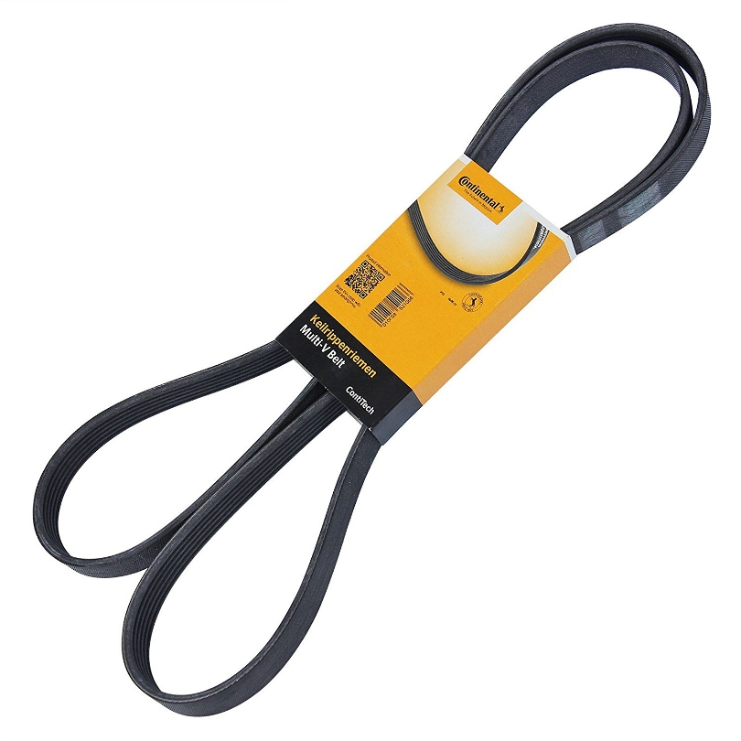
5PK1100 - 350
5PK1219 - 348

5PK1219
CITROEN BERLINGO 1.6 16V

CITROEN
BERLINGO (MF) -1996.07
1.6 16V (MFNFU) (109 KM) 2000.10- 1587 ccm80 kW 4 cyl
BERLINGO nadwozie pełne (M_) -1996.07
1.6 16V (109 KM) 2000.10- 1587 ccm80 kW 4 cyl

MITSUBISHI COLT 1.1 1.3 1.5

MITSUBISHI
COLT CZC kabriolet -2006.05
1.5 (109 KM) 2006.05- 1499 ccm80 kW 4 cyl
COLT VI (Z_) -2004.06
1.1 (75 KM) 2004.10- 1124 ccm55 kW 3 cyl
1.3 (Z35A, Z33A, Z34A) (95 KM) 2004.06- 1332 ccm70 kW 4 cyl
1.5 (Z36A) (109 KM) 2004.06- 1499 ccm80 kW 4 cyl
COLT VII (CZ_) -2008.09
1.1 (Z32AM, Z31AM) (75 KM) 2008.09- 1124 ccm55 kW 3 cyl
1.3 (Z35AM, Z34AM, Z33AM) (95 KM) 2008.09- 1332 ccm70 kW 4 cyl
--------------------------------------------
PK040338 - 213

PK40338(4PK860)
BMW 745i
BMW X5 4.4i 4.8is

BMW
7 (E65, E66) -2001.11
745 i,Li (333 KM) 2001.11- 4398 ccm245 kW 8 cyl
X5 (E53) -2000.05
4.4 i (320 KM) 2003.12- 4398 ccm235 kW 8 cyl
4.8 is (360 KM) 2004.04- 4799 ccm265 kW 8 cyl
PK050385 - 114

PK050385 ( 5PK980 )
BMW M5 E39
BMW 730 E32
BMW Z8 E52

BMW
5 (E39)2003.06 -1995.11
M5 (400 KM) 1998.10-2003.06 4941 ccm294 kW 8 cyl
7 (E32)1994.09 -1986.09
730 i,iL V8 (218 KM) 1992.04-1994.09 2997 ccm160 kW 8 cyl
740 i,iL V8 (286 KM) 1992.04-1994.09 3982 ccm210 kW 8 cyl
Z8 (E52)2003.06 -2000.06
4.9 (400 KM) 2000.06-2003.06 4941 ccm294 kW 8 cyl
PK040355 - 234
9PJ920EL - 617

ORIGINAL
HATZ 502 03101
9PJ 920 EL

Verwendung: HATZ 2L31 2L40 2L41 3L31 3L30S 3L30Z

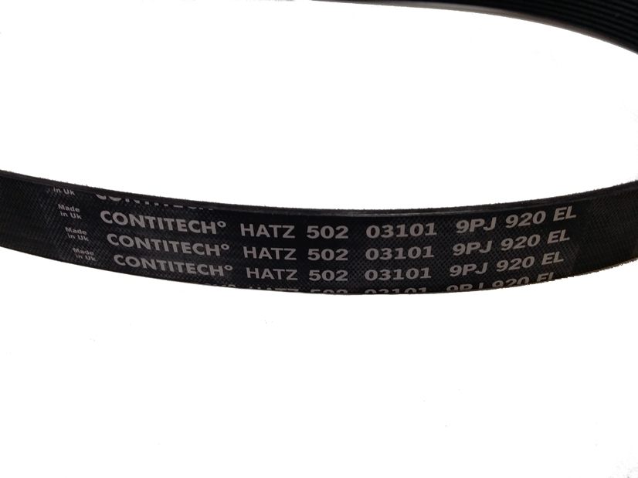

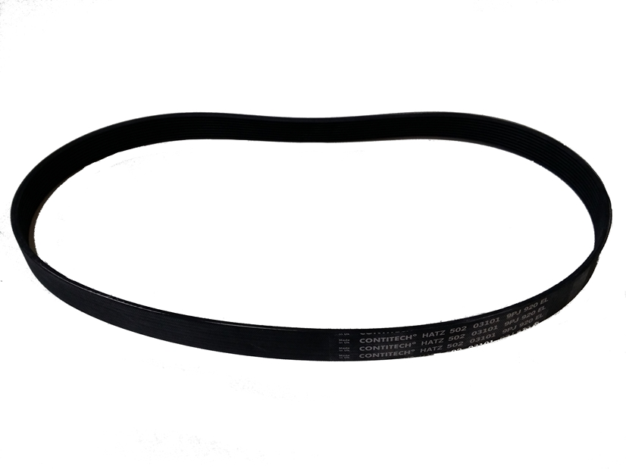
6PK2257 - 143
PK060882 - 299

PK060882 ( 6PK2240 )
MERCEDES C KLASSE W202 S202

MERCEDES-BENZ
KLASA C (W202)2000.05 -1993.03
C 200 CDI (202.134) (102 KM) 1998.03-2000.05 2151 ccm75 kW 4 cyl
C 220 CDI (202.133) (125 KM) 1997.09-2000.05 2151 ccm92 kW 4 cyl
KLASA C kombi (S202)2001.03 -1996.06
C 200 T CDI (202.194) (102 KM) 1998.03-2001.03 2151 ccm75 kW 4 cyl
C 220 T CDI (202.193) (125 KM) 1997.09-2001.03 2151 ccm92 kW 4 cyl
JOHN DEERE
L114489(8PK1930) - 500

ORYGINAL JOHN DEERE Keilriemen
L11489 ( 8PK1930 )

Verwendung:
John Deere 6010 • John Deere 6110 • John Deere 6210 • John Deere 6310 • John Deere 6410 • John Deere 6010SE • John Deere 6110SE • John Deere 6210SE • John Deere 6310SE • John Deere 6410SE • John Deere 6020 • John Deere 6120 • John Deere 6220 • John Deere 6320 • John Deere 6420 • John Deere 6420S • John Deere 6020SE • John Deere 6120SE • John Deere 6220SE • John Deere 6320SE • John Deere 6420SE •
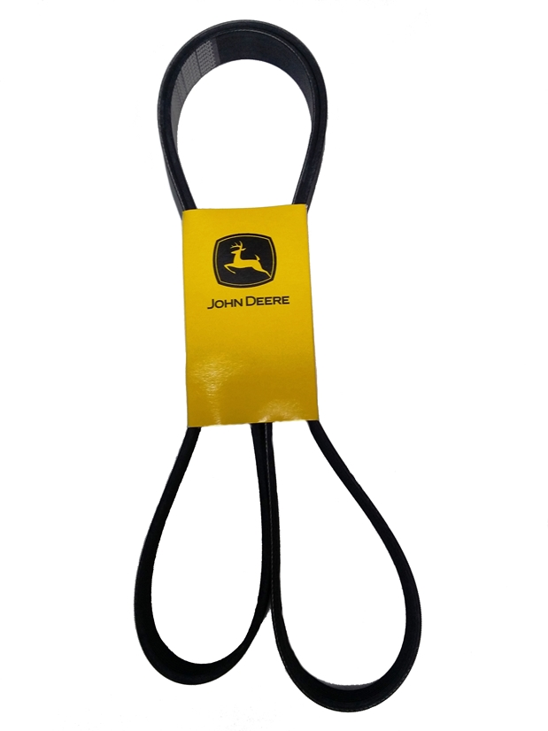
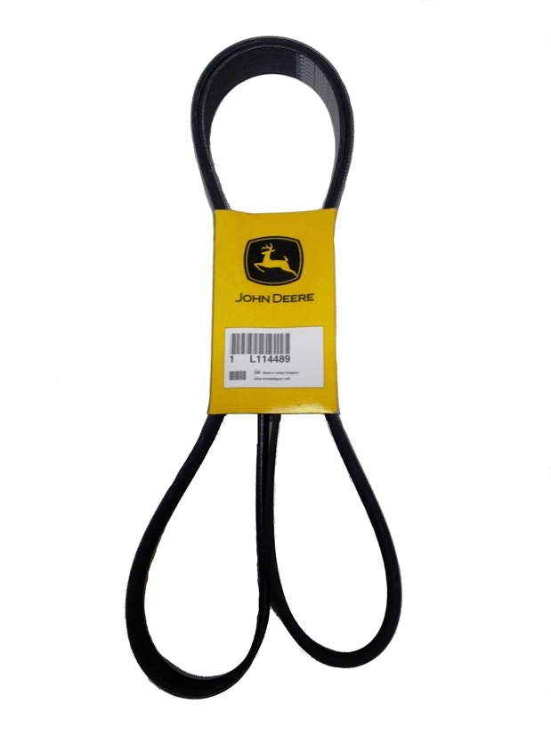
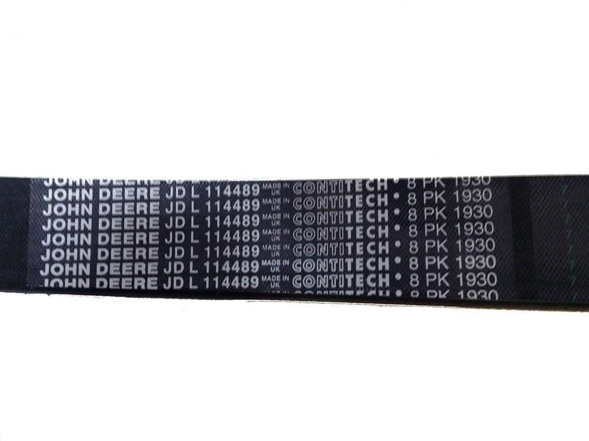
L111600(8PK2460) - 701

ORIGINAL JOHN DEERE Multi V-Belt
L111600 ( 8PK2460 )

Matching:
John Deere 6310 • John Deere 6410 • John Deere 6510 • John Deere 6610 • John Deere 6310SE • John Deere 6410SE • John Deere 6510SE • John Deere 6610SE • John Deere 6620 •

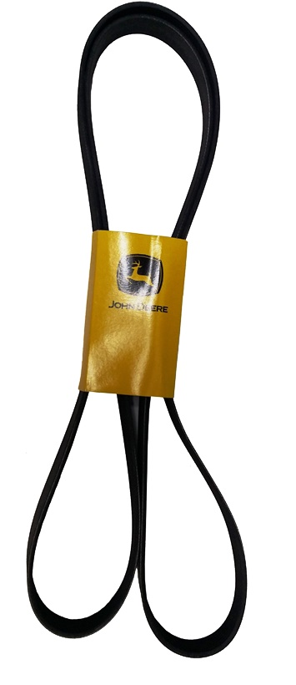
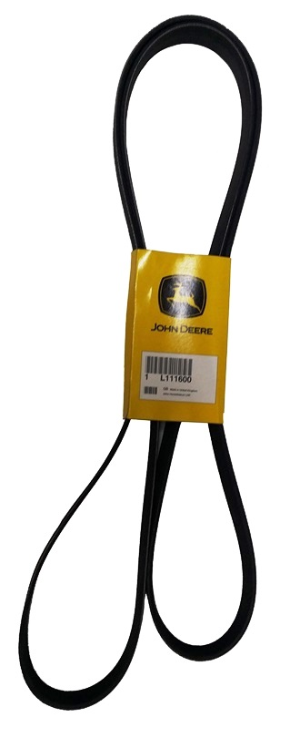
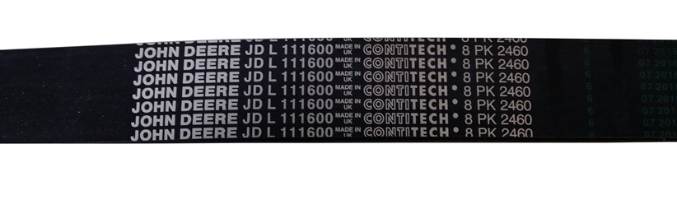
Take all price 1,99 EURO/belt

